CSS 534 HW2 Report
Hongbin Li

Execution Snapshots

MASS
Sequential result:
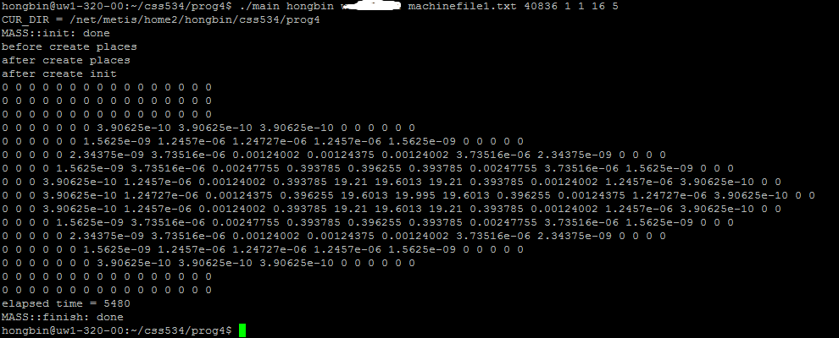
4 nodes 4 threads parallel result:
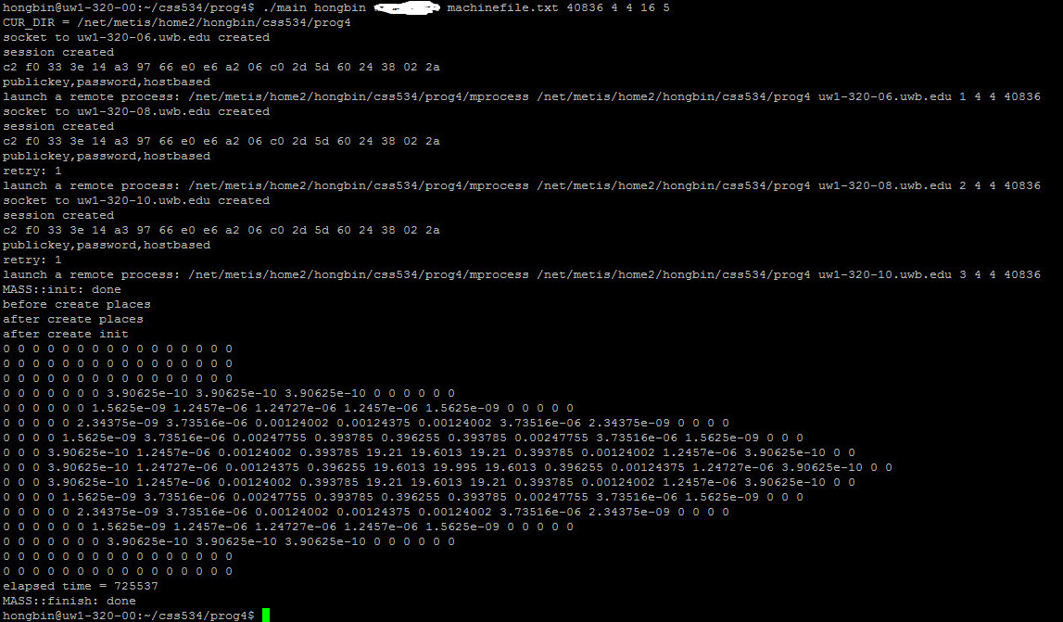

openMP MPI
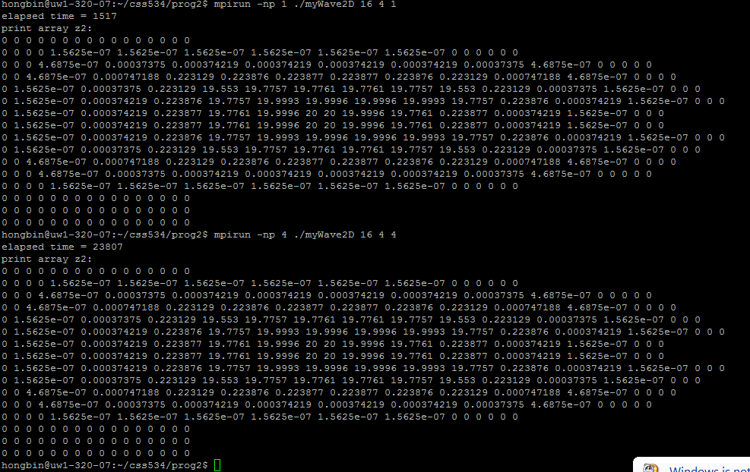

Since the way I initialize wave[0] is slight different, so results of MPI and MASS are different.

Performance Analysis

openMP MPI
Nodes\Processors | 1 | 2 | 3 | 4
1 | 20437613 | 10534868 | 7626821 | 6512875
2 | 11403357 | 6426491 | 4981659 | 4383526
3 | 8247563 | 4967236 | 3979956 | 3543918
4 | 6809594 | 4316624 | 3490746 | 3343974
5 | 5938534 | 3848640 | 3200153 | 3108202
6 | 5238958 | 3569690 | 3023588 | 2827049
7 | 4931237 | 3410465 | 2910002 | 2705939
8 | 4583090 | 3250185 | 2862426 | 2630220
9 | 4390482 | 3178010 | 2820737 | 2620771
10 | 4118371 | 3106860 | 2817696 | 2613082
11 | 3986492 | 3029191 | 2674465 | 2923652
12 | 3887729 | 2952785 | 2711037 | 2873350
13 | 3744192 | 2948290 | 2655285 | 2818775
14 | 3639201 | 2942686 | 2763380 | 2802836
15 | 3613785 | 2933395 | 2680866 | 2753109
16 | 3594337 | 2891919 | 2671121 | 2794062

MASS
Nodes\Processors | 1 | 2 | 3 | 4
1 | 100432357 | 53438373 | 37326645 | 29831298
2 | 54184986 | 28859919 | 24119099 | 20438842
4 | 36068034 | 25979561 | 23175439 | 23287079

MASS Programmability Analysis

Q1. State your time (in hours) needed to complete your HW2 and HW4 respectively.
Programming Stages | Hours you have spent for hybrid MPI/OpenMP | Hours you have spent for MASS
To learn the library | 4 | 2
To design the program | 3 | 1
To write the program | 6 | 2
To debug the program | 6 | 3

Q2. State the code size (in lines) of your HW2 and HW4 respectively.
 | Hybrid MPI/OpenMP version | MASS version
Total lines (excluding comments) | 250 | 150
Parallelization-specific code | 55 | 10

Q3. State the programmability of HW2 and HW4: 1 quite hard, 2: hard, 3: fair, 4: good, 5: excellent
 | Hybrid MPI/OpenMP version | MASS version
Learning curve | 3 | 5
The suitability to your application | 4 | 4
Degree of difference between sequential and parallel programs  (1: big – 5: little difference) | 1 | 5
Debugging difficulty | 2 | 5

Q4. State the degree of easiness of the following MASS functions when you wrote your program, as compared to MPI/OpenMP functions: 1: quite hard, 2: hard, 3: fair, 4: easy, 5: quite easy, X: not used
MASS functions | Degree of easiness
Places/Agents.callAll | 5
Places.exchangeAll | 5
Agents.manageAll | X

Q5. Estimate the degree of the following future functions’ usefulness for your HW4 application as well as any applications you would like to code in the future: 1: not useful at all 2: probably not useful 3: maybe useful 4: useful, 5: quite useful
Future MASS functions | Degree of usefulness
Places.callSome | 5
Places.exchangeBoundary | 4
Agent.migrate (part 1): agent diffusion | 5
Agent.migrate (part 2): collision avoidance | 5
Parallel file I/Os | 5
Optimistic synchronization | 5

Q6. State the merits and demerits of hybrid MPI/OpenMP and MASS respectively.
Hybrid MPI/OpenMP merits: explicitly control data split. Flexible. | Hybrid MPI/OpenMP demerits: tedious of data boundary control, hard to debug,
MASS merits: easy to program and debug | MASS demerits: some control in MASS library, create many place objects will occupy more memory.

Q7. In addition to your HW4 application, what applications else can you think take advantage of MASS?
Distributed grep.

Q8. Please report any bugs in MASS you found while you were developing your application.
No bugs found (if so, check the right box)
Yes, some bugs found (if so, check the right box and list the bugs below) | YES

Bug # | Descriptions
1 | Sequential result is different from parallel result. because I forget to set inMessage_size as double.
2

Q9. May the professor’s research group use your report for their future funding proposal submissions and paper publications, provided your name is recognized in acknowledgments/references or listed as one of our co-authors?
YES: YES
YES under some conditions. Please write the conditions below:

NO

